**How to install Origin 2015 in Microsoft Window 10**

1. **Run the Download setup file of Origin 2015 and click on Next Button.**

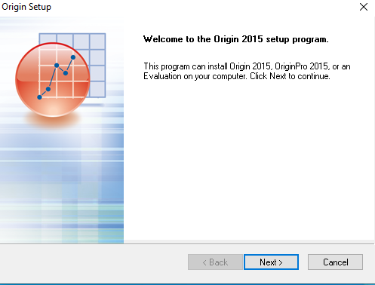

1. **Click on “YES” button.**

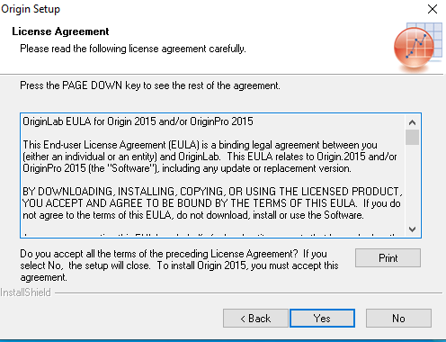

1. **Select “Install Product (requires Serial Number)” button.**

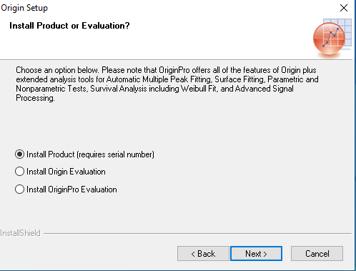

1. **Enter the serial number supplied to you by email and Click on “Next Button”.**

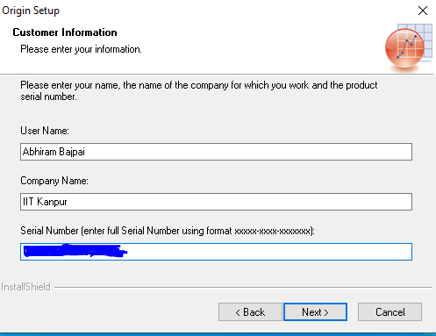

1. **Click on “YES” Button.**

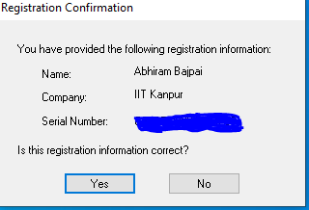

1. **Select “YES, Launch Origin as Administrator after the installation finishes.” And click on “Next” button.**

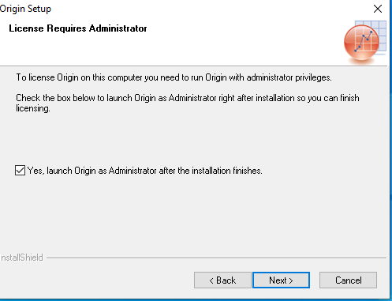

1. **Choose to install the required version 64 or 32 bit or both 32 & 32 bit and click on “Next” button.**

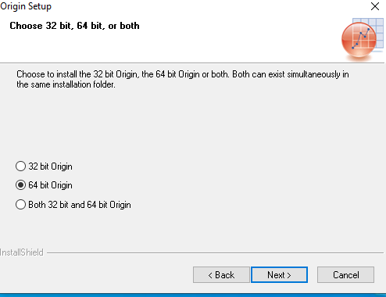

1. **Specify the destination directory and click on “Next” Button.**

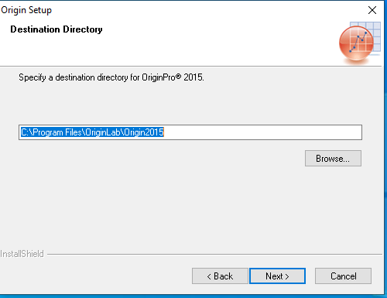

1. **Click on “YES” button.**

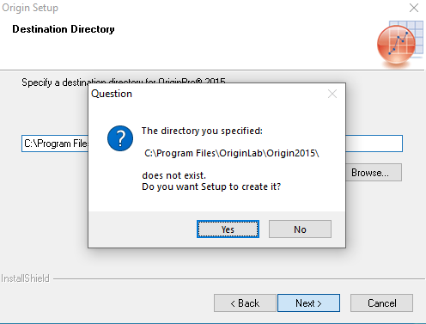

1. **Select “English Help Files” if Required and click on “Next” button.**

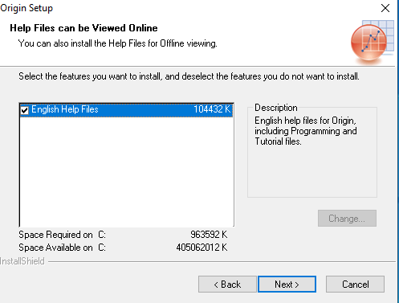

1. **Choose installation for “All Users” and click on “Next” button.**

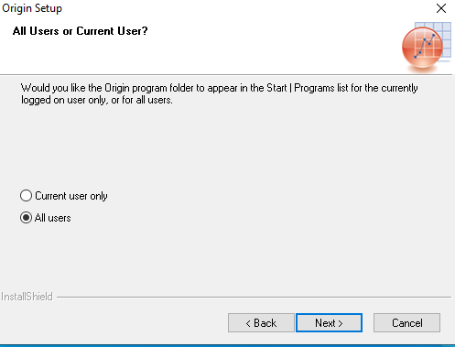

1. **Click on “NEXT”button.**

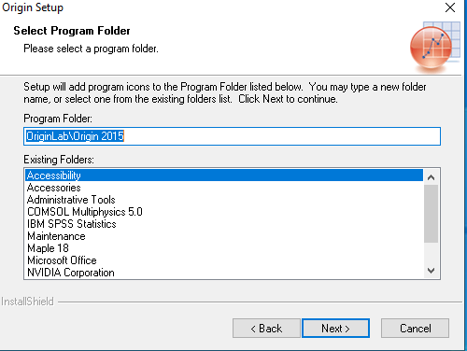

1. **Click on “NEXT” button.**

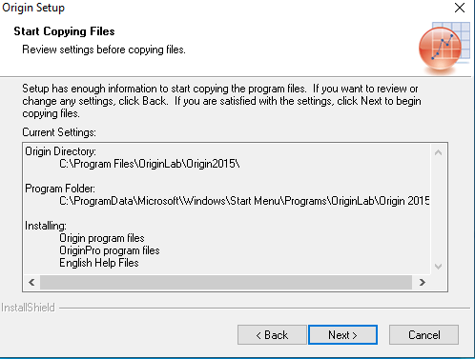

1. **Just Wait a few minute till installation finishes.**

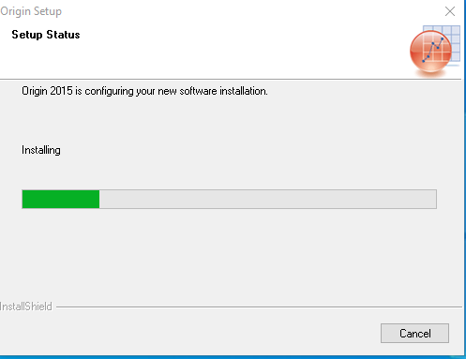

1. **Click on “Finish” button.**

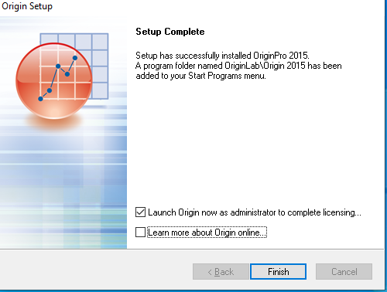

1. **Specify the “Users Files Folder” and click on “OK” button.**

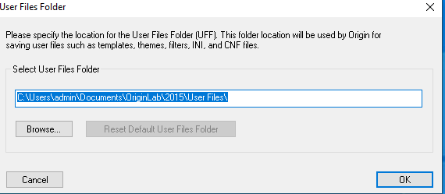

1. **Enter the Licence Inforamtion ( Licence Server is 172.31.1.17, Port No.2081) click on “Update” button and close the box.**

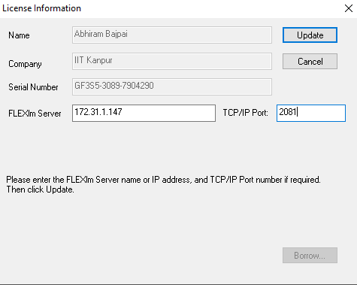

1. **Click on “OK” button”**

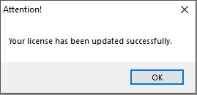

1. **Check “Do not show this dialog in the future” and click “NO” button.**

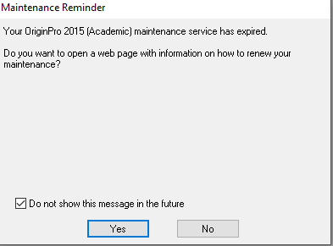

1. **Again check “Do not show this dialog in the future” for setup tips daialog box and click “Close” button.**

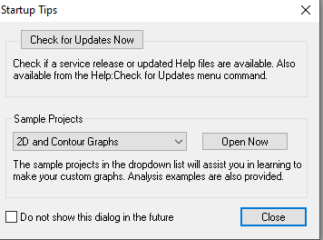

1. **The Preview of this software are:**

